Task-3: Web Application Security Report

Student Name: Hardik Prakash Kotawdekar
Offer Letter ID: APSPL2635998
Date: 28 Jun 26

- Introduction
This report covers the exploitation of OWASP Top 10 vulnerabilities in DVWA (Damn Vulnerable Web Application) as part of ApexPlanet Cybersecurity Internship Task-3.
- Lab Setup
- Attacker: Kali Linux
- Target: Metasploitable2 (DVWA)
- Security Level: Low
- Exploits Performed
SQL Injection
- Successfully dumped users table using UNION-based injection.
- Payloads used: 1' UNION ALL SELECT user,password FROM users --
- Retrieved multiple usernames and passwords (including admin).

Cross-Site Scripting (XSS)
- Stored XSS: Executed alert script successfully.
- Reflected XSS: Also demonstrated.

CSRF
- Created malicious HTML form to change password without user consent.

File Inclusion
- Local File Inclusion (LFI): Read /etc/passwd successfully.

Burp Suite
- Intercepted and modified login requests.
- Performed basic fuzzing with Intruder.

- Screenshots (Insert your screenshots here with captions)
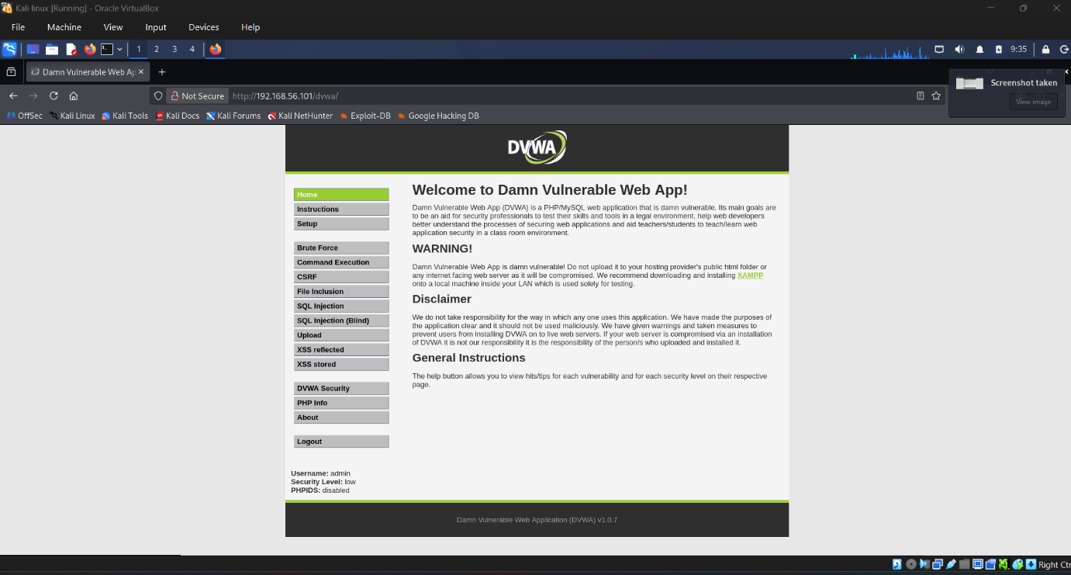
DVWA Home page

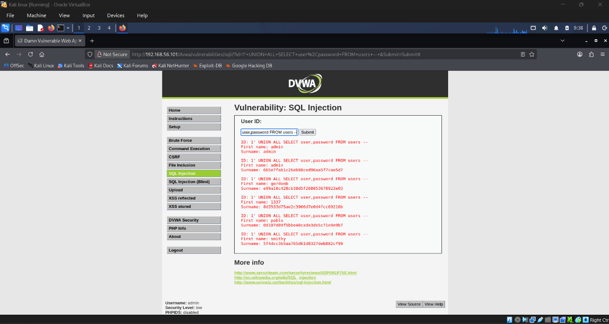
SQL Injection

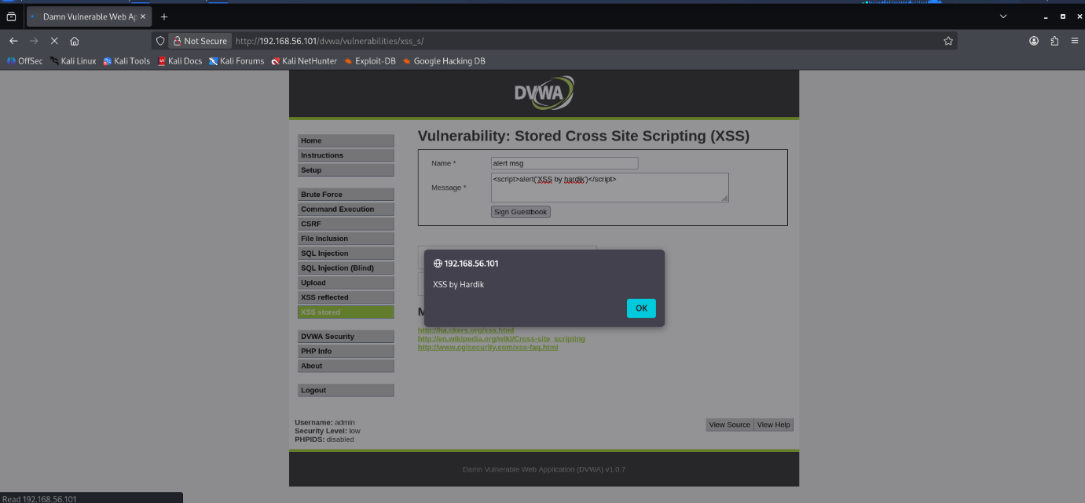
XSS Stored
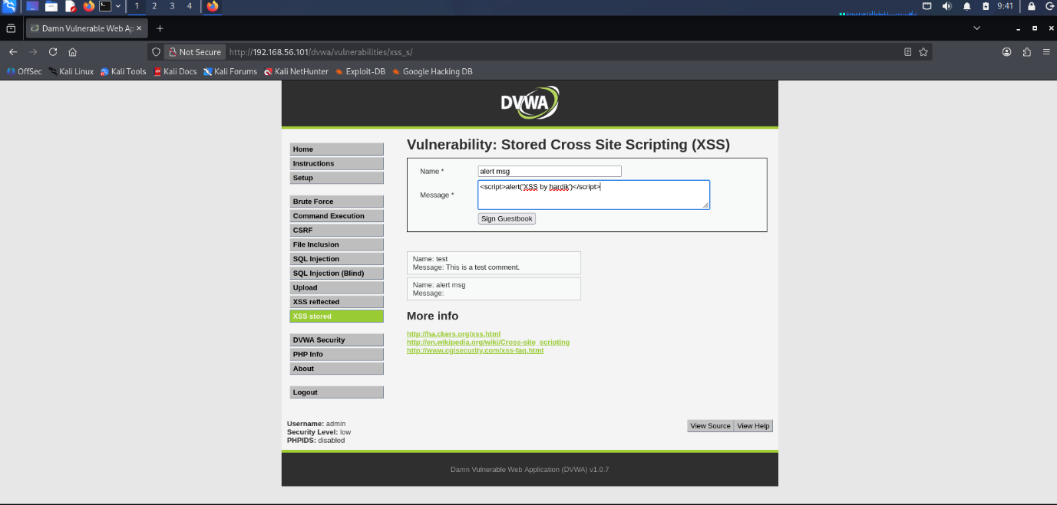
XSS Stored

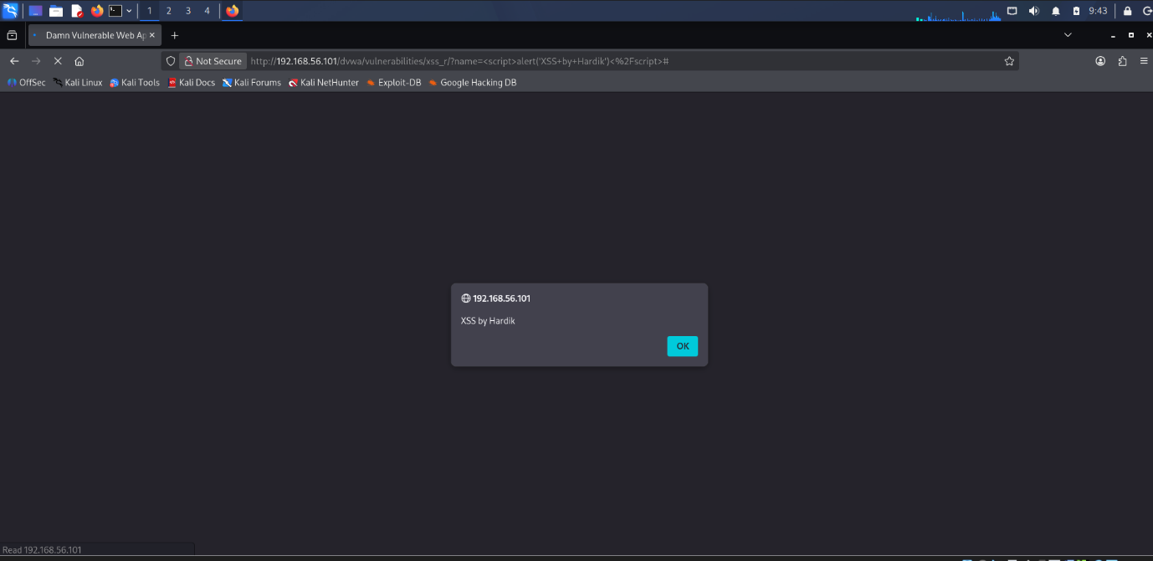
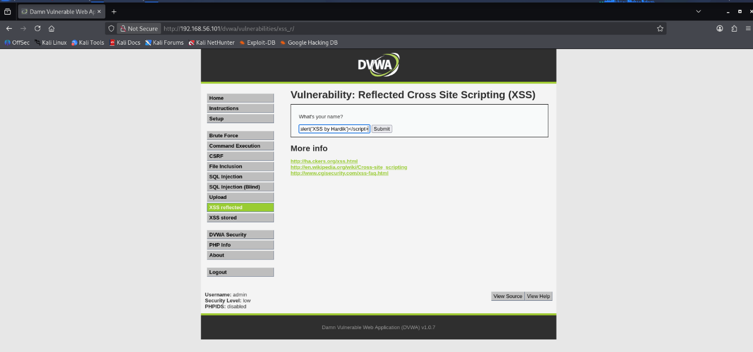

XSS Reflected

XSS Reflected

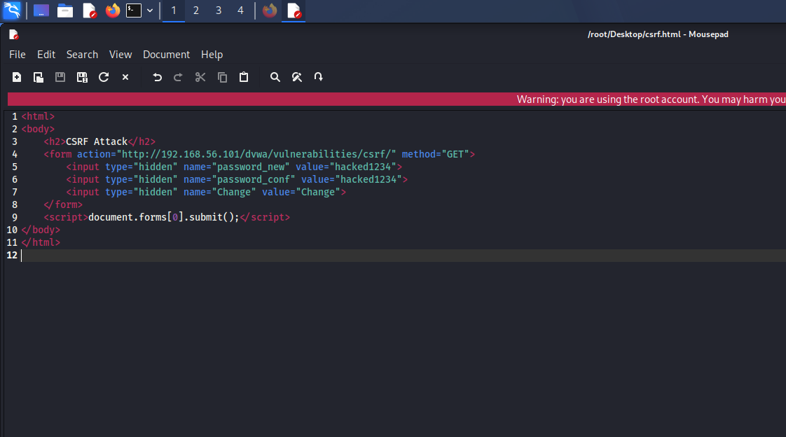
CSRF: Malicious HTML code
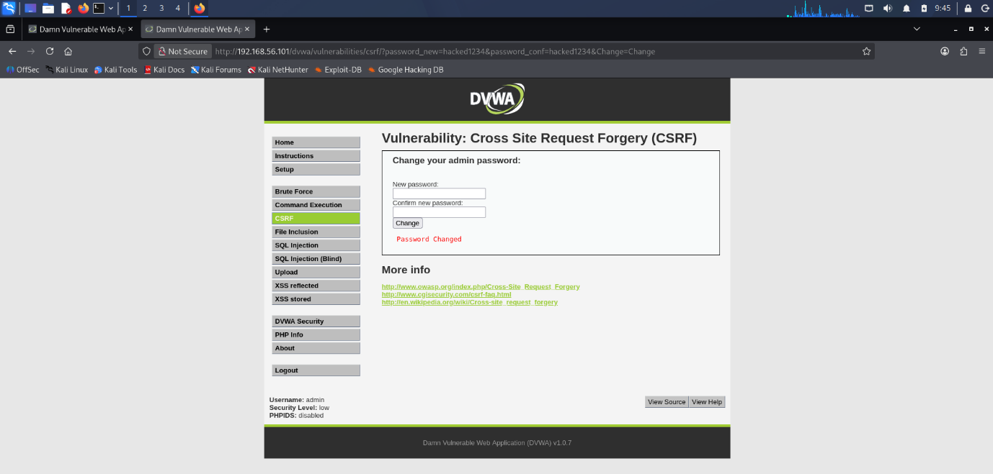
CSRF: Password changed without clicking

File Inclusion (LFI): /etc/passwd content displayed
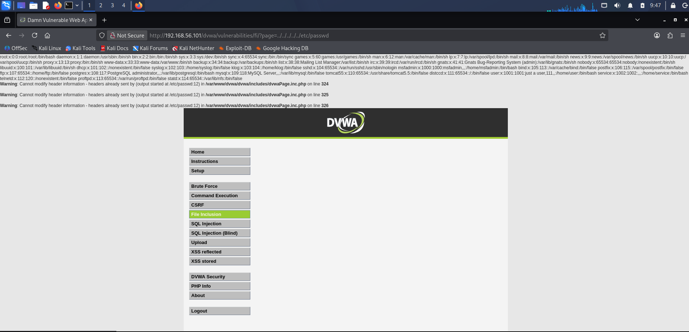

Setting proxy to browser

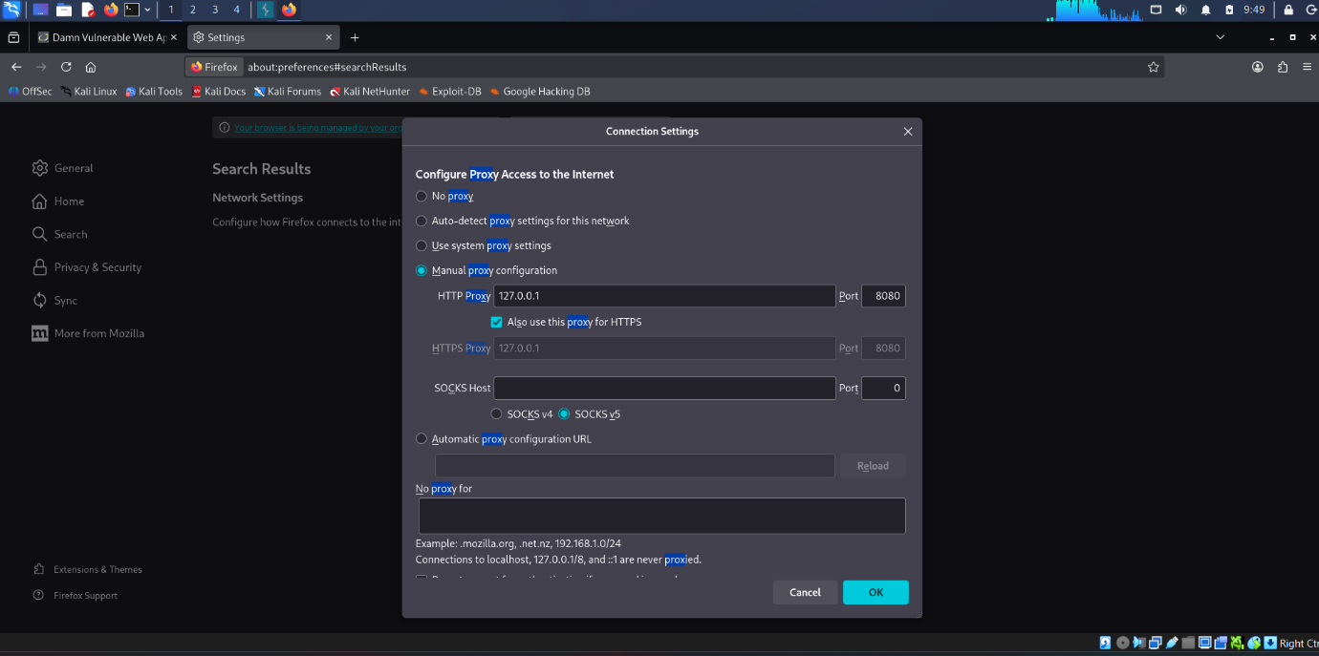
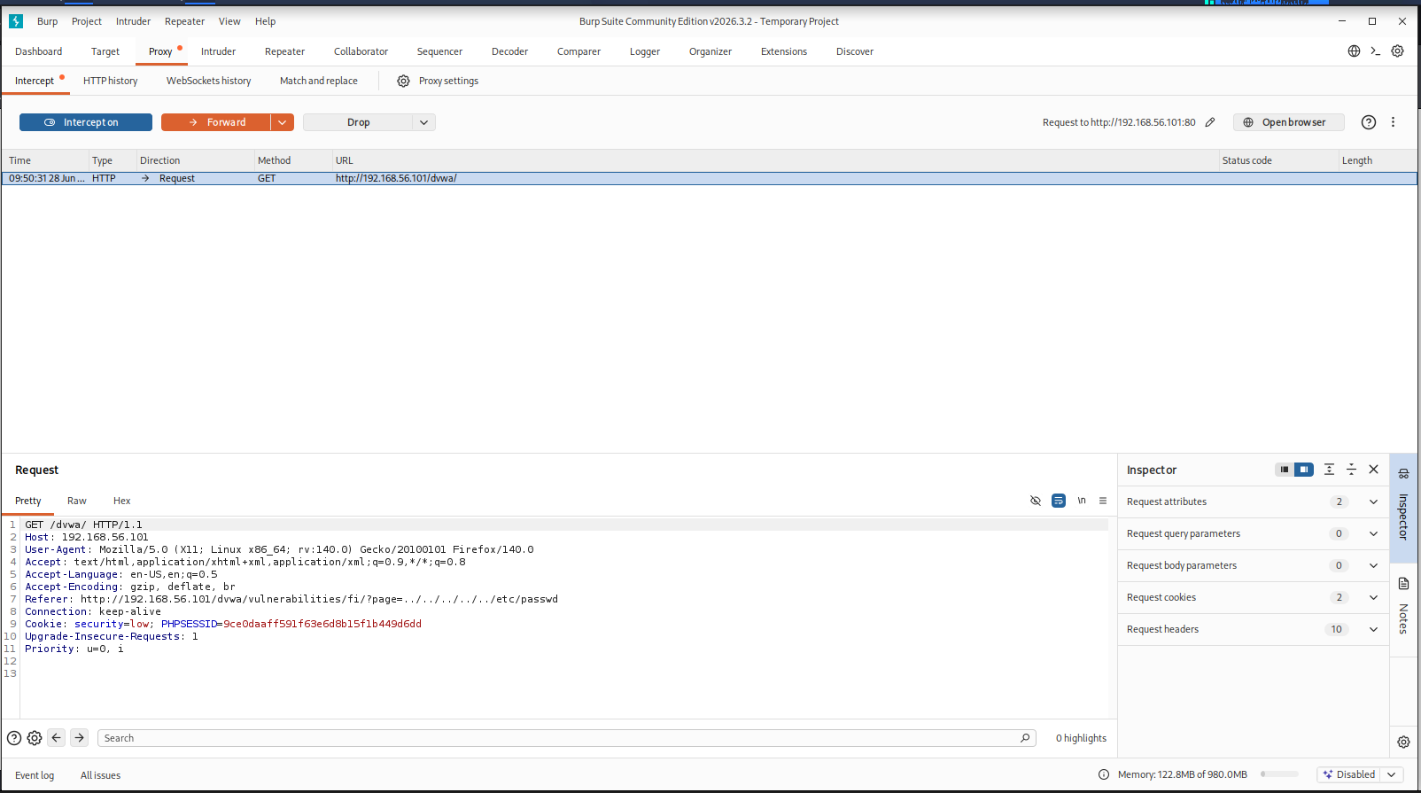
Burp Suite: Proxy intercepting a request
- Mitigation Recommendations
- Use Prepared Statements for SQLi
- Implement CSP and input validation for XSS
- Use anti-CSRF tokens
- Validate and sanitize file paths for File Inclusion

- Conclusion
Successfully identified and exploited multiple web vulnerabilities in a controlled environment. Gained practical experience with OWASP Top 10.

